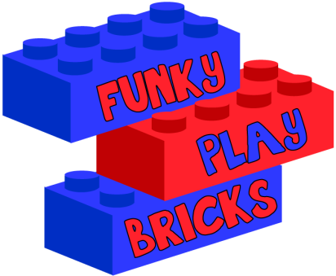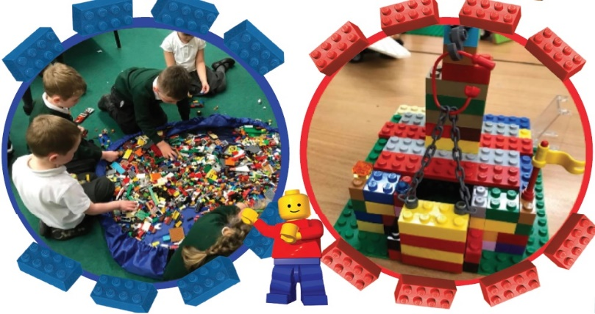

Funky Play Bricks After School Club
Our LEGO® After School Club will continue after May Half term.
The Funky Play Bricks session will run on Tuesdays.
This Club will be open for to all children.
Our clubs will be run from 2nd of June until 14th of July 2026.
This club will be providing funky interactive structured play sessions with an educational twist. Each week will see a new challenge created for the children to solve by building objects, buildings, and vehicles.
It will run from 3:20 until 4:30pm and will cost £5.00 per week.

Half term fee is £35.00 (7 weeks)

There are 25 places available. SPACES will be offered on a first come first serve basis. To apply for one of these spaces you will need to complete an online booking form via the Funky Play Bricks website.
Booking details can be found below.
How to book a place for your child
Visit the following website.
https://www.funkyplaybricks.co.uk/freegrounds-juniors/
this will bring up the Funky Play Bricks booking form. Please fill in all the details required, add your payment details and then Funky Play bricks will be in touch to confirm the details.
We can’t wait to continue building at the After School Club with you!!!

Yours sincerely
Funky Play Bricks

